 | Division  Apparel | Test Method ID  PHM-AP0437 |  | Version  03 | Page: 1-4
Effective Date:
Feb. 1st, 2021
Tiecord Ends/Buttons Pull Test |  |  |  |  | Effective Until:  Further Notice
Document Owner:
Advanced Creation Testing – Lab Standards
Document Author:  Matthias Walter  Manager Lab Standards |  |  | Document Approver:  Dr. Michael Otto  Senior Manager Lab Standards
Applicability - Brand: Adidas, Reebok |  |  | Division: Apparel

- Objective
Determination that a tie cord end/button is attached correctly to prevent
separation or complete detachment during use.
This test can be applied to any projection that can be grasped with thumb and
forefinger or teeth.

- Scope
The tiecord/button is held by grips and pulled at a specific force for a certain period (10s), any detachment/distortion will be reported.

- Referenced documents

EN 71-1: 2018

Safety of toys - Part 1: Mechanical and physical properties

- Terminology/Hardware/Equipment
According to referenced document.
+ Adidas Modification

1. Tension device: shall be a self-indicating gauge or other appropriate means applying forces up to at least 90N with an accuracy of +/-2N (see figure 1)

2. Clamps: capable of holding and applying a tension load to the test component (buttons, tiecords etc.) in parallel and perpendicularly to the major axis, without affect the structure integrity of the test specimen (see figure 2)

Recommended equipment:
SDL Atlas G201AA Snap Tester_Safety testing equipment for Snaps, Buttons and other Garment Attachments
SafeGuard Universal Mechanical Safety Tester

- Procedure
+ Adidas Modification

a) Tiecord ends: 70N

Position the tie cord end into the recess in the clamp.
Secure tie cord end by turning lever arm accordingly.
Set the pointer to zero position by adjusting the lever.
Lock firmly
Elevate the scale by rotating the top flywheel thus inducing a force on the attached tie cord end.
Gradually apply a force of 70N within a period of approximately 5s. Maintain the force for 10s.
Remove the force and check carefully if there’s any detachment or distortion on tiecord.
Continue testing the remaining specimens.

b) Buttons/Snap buttons/eyelets/rivets: 90N

Mount the button on tension device with suitable clamps.

Set the force start pointer to zero position.

Gradually apply a tensile force of 90N within a period of approximately 5s parallel to the major axis of the test component, maintain the force for 10s.

Remove the force; carefully check if there is any detachment, break or distortion.

Possible Broken state: BOBB: bridge of button broken
BF: button fractured
FR: fabric ruptured
STB: sewing thread broken

Continue testing the remaining specimens.

Important Note: if a torque test is required for the same sample, the tension test should be conducted on the same part of the same test piece that was torque tested.

- Data collection, evaluation and reporting
  - Data collection and reporting
- Report the value of the force and broken state.

  - Evaluation/measuring
According to referenced document.
Refer to the Quality Assurance Test Matrix for test method requirements.

- Quality Assurance
- The laboratory must take the full responsibility of the machines, devices and tools to be calibrated/controlled regularly in order to fulfill the required tolerance mentioned in the Adidas/Reebok test standards.

- Safety
It is the user’s responsibility to practice laboratory safety procedures in handling all materials in this test method. All national standards and rules and adidas laboratory guidelines and procedures shall be consulted and followed. This safety statement is not all-inclusive and is for informational purposes only. Refer to your country’s safety guidelines for all safety regulations.

- Document version history
Version | Date | Author | Notes
03 | 2021-02-01 | Matthias Walter | Complete new written; updated and aligned for CMA/aTP-system

- Appendix
Equipment photos from Tension Device “Snap Tester” (Figure 1) and Clamps “Upper Stud Grip” (Figure 2)

Figure 1
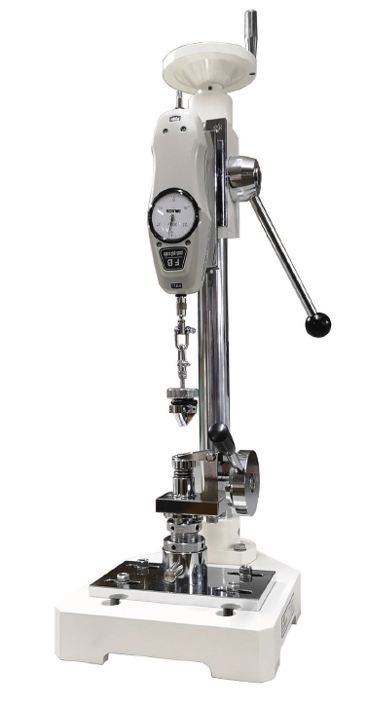

Figure 2
